# *Database Management I (420-D10-HR)*

# *Lab 08 – Attributes and Generalization in Entity Relationship Diagrams*

Date assigned: Monday, September 26, 2016

Date due: **Monday, September 26, 2016, 4:50pm**

**Learning Objectives**

Upon successful completion of this lab exercise, the student will be able to:

1. categorize attributes according to atomicity, explicitness, multiplicity, optionality and uniqueness
2. identify possible generalizations and specializations in a data model.

**To Be Handed In:**

1. The completed ***username*_D10_L08_Generalization** foldershould be zipped and uploaded to **Moodle**.

**To Start:**

1. Download and unzip the **D10_L08_Generalization** folder from **Moodle** to your **420-D10\Labs** folder. Rename it to ***username*_D10_L08_ Generalization**.
2. Copy your completed data models to the appropriate locations in this document.

**Marks**

|  |  |  |  |
| --- | --- | --- | --- |
| **Question** | | **Mark** | **Out Of** |
| A | 1. Airline Identifiers |  | 6 |
|  | 2. Airline Attributes |  | 36 |
|  | 3. Attributed Data Model |  | 5 |
| B | 1. Airline Data Model |  | 10 |
| C | 1. Library Data Model |  | 11 |
|  | 2. Rental Car Agency |  | 3 |
| Organization | |  | 3 |
| **Total** | |  | **74** |

# Attributes

***Purpose:*** Learn to categorize attributes according to atomicity, explicitness, multiplicity, optionality and uniqueness, to clearly define attributes and to determine the entity or relationship to which an attribute belongs.

***To Do:***

## Refer to Appendix I for the data model, business rules and sample forms for the airline system.

## Identify an appropriate identifier for each regular entity in the airline system. List the identifiers in Table 1 in ***username*_D10_L08_Generalization.docx**.

**Table 1**: Identifiers for the Airline System

|  |  |
| --- | --- |
| **Entity** | **Identifier name** |
| CREW | crewId |
| AIRCRAFT | aircraftId |
| SCHEDULED FLIGHT | flightId |
| FLIGHT | flightId |
| CITY | cityCode |
| PASSENGER | passengerId |

## Review the documentation in Appendix I and complete the airline system attribute table (Table 2) with the airline system attributes.

**Table 2**: Attributes for the Airline System

| **Attribute** | **Entity** | **Atomic or Composite (A or C)?** | **Explicit or Derived (E or D)?** | **Singular or Multi-valued (S or M)?** | **Mandatory or Optional (M or O)?** | **Unique Identifier (Y or N)?** |
| --- | --- | --- | --- | --- | --- | --- |
| crewId | Crew | Atomic | Explicit | Single | Mandatory | Yes |
| crewName | Crew | Composite | Explicit | Multi | Mandatory | No |
| crewPosition | Crew | Atomic | Explicit | Single | Optional | No |
| certificationDate | certifiedCrew | Atomic | Explicit | Single | Optional | No |
| aircraftId | certifiedCrew | Atomic | Explicit | Single | Mandatory | Yes |
| crewId | certifiedCrew | Atomic | Explicit | Single | Mandatory | Yes |
| aircraftId | Aircraft | Atomic | Explicit | Single | Mandatory | Yes |
| aircraftType | Aircraft | Composite | Explicit | Multi | Mandatory | No |
| crewId | flightCrew | Atomic | Explicit | Single | Mandatory | Yes |
| flightRole | flightCrew | Atomic | Explicit | Single | Optional | No |
| flightId | flightCrew | Atomic | Explicit | Single | Mandatory | Yes |
| flightId | scheduledFlight | Atomic | Explicit | Single | Mandatory | Yes |
| DepartureCity | scheduledFlight | Atomic | Explicit | Single | Mandatory | No |
| DepartureDate | scheduledFlight | Atomic | Explicit | Single | Optional | No |
| DepartureTime | scheduledFlight | Atomic | Explicit | Single | Optional | No |
| ArrivalCity | scheduledFlight | Atomic | Explicit | Single | Mandatory | No |
| ArrivalDate | scheduledFlight | Atomic | Derived | Single | Optional | No |
| ArrivalTime | scheduledFlight | Atomic | Derived | Single | Optional | No |
| flightId | Flight | Atomic | Explicit | Single | Mandatory | Yes |
| aircraftId | Flight | Atomic | Explicit | Single | Optional | Yes |
| DepartureCity | Flight | Atomic | Explicit | Single | Mandatory | No |
| ArrivalCity | Flight | Atomic | Explicit | Single | Mandatory | No |
| CityCode | City | Atomic | Explicit | Single | Mandatory | No |
| cityName | City | Atomic | Explicit | Single | Mandatory | No |
| cityLocation | City | Atomic | Explicit | Single | Optional | No |
| flightId | reservedFlight | Atomic | Explicit | Single | Mandatory | Yes |
| passengerId | reservedFlight | Atomic | Explicit | Single | Mandatory | Yes |
| dateOfReservation | reservedFlight | Atomic | Explicit | Single | Mandatory | No |
| passengerId | Passenger | Atomic | Explicit | Single | Mandatory | Yes |
| passengerName | Passenger | Composite | Explicit | Multi | Mandatory | No |
| passportId | Passenger | Atomic | Explicit | Single | Optional | Yes |
| reservationId | Passenger | Atomic | Explicit | Single | Mandatory | Yes |
| phoneNumber | passenger | Atomic | Explicit | Single | Optional | No |

## Open the airline data model that is in the ***username*_D10_L08_ Generalization** folder. Add the identifiers and attributes identified in the previous steps to the appropriate entity. If you identified any additional entities, add them. Save the completed diagram.

*Insert Diagram here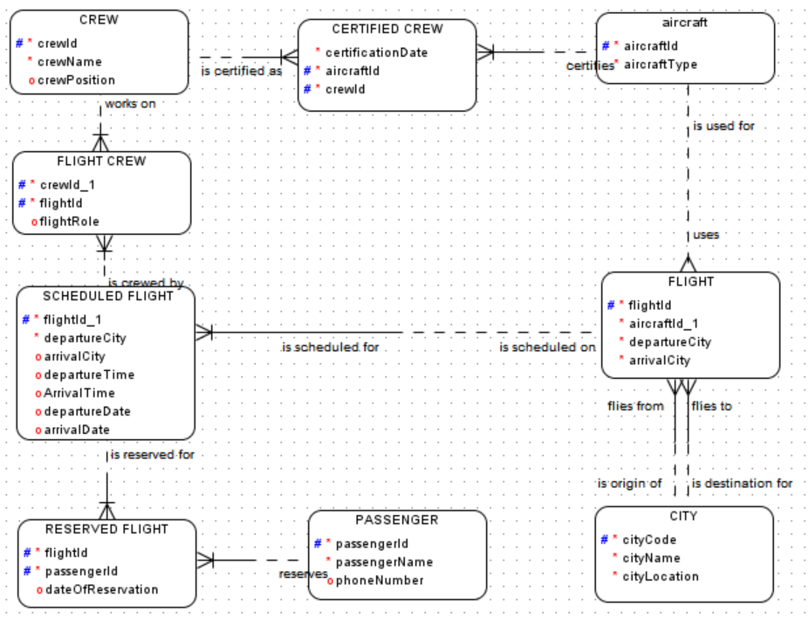*

# Specialization

***Purpose:*** Learn how to recognize when ***specialization*** would benefit a data model.

**To Do:**

## For the airline system, refer to the business rules in Appendix I to answer the following.

### Use specialization to identify a possible inheritance hierarchy for the CREW entity.

The certified crew entity inherits from the crew entity

### Add the inheritance hierarchy to the diagram that you modified in the previous question.

**To create an inheritance hierarchy**:

1. Create the supertype

2. Create the subtype. Select the supertype entity from the Super Type drop down box in the entity properties frame.

### Save the diagram here:

### 

# Generalization

***Purpose:*** Learn when to ***generalize*** a number of entities.

**To Do:**

## Consider the Library System entity relationship diagram in Appendix II.

### Identify any entities with a common set of attributes and/or relationships and create a generalization hierarchy for them.

### Modify the entity relationship diagram that is in the ***username*_D10_L08_ Generalization** folder to include the generalizations that you found.

### Save the diagram here

## A rental car agency classifies the vehicles it rents into five categories: compact, mid-size, full-size, mini-van and sport utility. The agency wants to record the following data for all vehicles: vehicle_id, make, model, year and colour. There are no unique attributes for any of the five classes of vehicle. The vehicle entity has a relationship (named rents) with a customer entity. None of the five vehicle classes has a unique relationship with another entity. Would you consider creating a supertype/subtype relationship for this problem? Why or why not?